Solar System Using Virtual Reality
Submitted in partial fulfilment of the requirements of the degree of
BACHELOR OF COMPUTER ENGINEERING
by
Anurag Sanjay Kawade (21102013)
Atharv Santosh Darekar (21102036)
Shefali Vinay Jain (21102023)
Shruti Prasanna Khanvilkar (21102084)

Guide:
Prof. Ramya R. B.


Department of Computer Engineering
- P. SHAH INSTITUTE OF TECHNOLOGY, THANE
(2024-2025)


A. P. SHAH INSTITUTE OF TECHNOLOGY, THANE

CERTIFICATE
This is to certify that the project entitled “Solar System Using Virtual Reality” is a bonafide work of “Anurag Sanjay Kawade (21102013), Atharv Santosh Darekar (21102036), Shefali Vinay Jain (21102023), Shruti Prasanna Khanvilkar (21102084)” submitted to the University of Mumbai in partial fulfilment of the requirement for the award of the degree of Bachelor of Engineering in Computer Engineering

_____________ _______________
Prof. Ramya R. B. Prof. D.S. Khachane
(Guide) (Project Coordinator)

_____________ _______________
Dr. S.H. Malave Dr. U.D. Kolekar
(Head of Department) (Principal)


A. P. SHAH INSTITUTE OF TECHNOLOGY, THANE
Project Report Approval for B.E.
This project report entitled “Solar System Using Virtual Reality” by Anurag Sanjay Kawade , Atharv Santosh Darekar , Shefali Vinay Jain , Shruti Prasanna Khanvilkar is approved for the degree of Bachelor of Engineering in Computer Engineering, 2024-2025.

Examiner Name Signature
1.

2.
Date:
Place:
D

Declaration
We declare that this written submission represents my ideas in my own words and where others' ideas or words have been included, I have adequately cited and referenced the original sources. I also declare that I have adhered to all principles of academic honesty and integrity and have not misrepresented or fabricated or falsified any idea/data/fact/source in my submission. I understand that any violation of the above will be cause for disciplinary action by the Institute and can also evoke penal action from the sources which have thus not been properly cited or from whom proper permission has not been taken when needed.

Anurag Sanjay Kawade - 21102013

Abstract
The integration of Virtual Reality (VR) in exploring the solar system offers an innovative approach to education, enhancing the understanding of astronomical concepts. By creating immersive environments, students can visualize and interact with celestial bodies in a way that traditional teaching methods cannot achieve. For instance, VR applications allow learners to manipulate the scale and distance of planets, providing a tangible sense of the vastness of space and the relationships between different astronomical entities. This hands-on experience not only makes learning more engaging but also helps students grasp complex concepts such as orbital mechanics and planetary motion through direct interaction with 3D model.
Moreover, VR technology facilitates collaborative learning experiences where students can work together to build and explore a 3D model of the solar system. Such projects encourage teamwork and critical thinking as students research and accurately position planets based on real astronomical data. This active participation fosters a deeper understanding of the solar system's structure and dynamics, as students are required to apply their knowledge creatively while developing technical skills in VR creation software. The educational potential of VR extends beyond mere visualization; it transforms abstract concepts into concrete experiences that resonate with learners.
In conclusion, the use of VR in solar system education represents a significant advancement in teaching methodologies. By bridging the gap between theoretical knowledge and practical application, VR not only enhances cognitive learning outcomes but also ignites interest in astronomy among students. As technology continues to evolve, the possibilities for implementing VR in educational settings will expand, paving the way for more immersive and effective learning experiences.

CONTENTS
- Introduction ............................................................................................1
- Literature Survey ....................................................................................2
- Limitation of Existing System ................................................................3
- Problem Statement, Objectives and Scope .............................................4
- Proposed System .....................................................................................5
- Experimental Setup .................................................................................6
- Project Plan .............................................................................................7
- Expected Outcome ..................................................................................8
- References ...............................................................................................9

LIST OF FIGURES
5.1

Chapter 1: Introduction

The solar system has always captivated our curiosity, and recent advancements in virtual reality (VR) have revolutionized how we can explore this vast, intricate expanse. VR offers an immersive, interactive platform for students and space enthusiasts alike to experience the wonders of our solar system firsthand. In a typical VR lesson, learners are no longer passive observers; they can now travel across the solar system, starting at the Sun and moving outward through the eight planets and other celestial bodies like asteroids and comets. This interactive learning environment allows users to comprehend abstract concepts like planetary distances, gravitational forces, and orbital mechanics more intuitively, making the universe more tangible than ever before.
Through VR, learners are given the tools to dive deep into the complexities of our solar system. For instance, they can zoom in to study the cratered surface of Mars or observe Saturn’s majestic rings up close, gaining a level of detail that static textbooks simply can’t offer. Platforms like Unity and CoSpaces Edu even empower students to create their own solar system models, allowing them to simulate planetary orbits and movements in real time. These hands-on activities foster creativity, deepen understanding, and provide an immersive way to grasp otherwise abstract scientific principles. Moreover, VR encourages collaborative learning, where students can work in teams to design planetary systems and share their findings, enhancing communication, problem-solving, and critical thinking skills.
In essence, VR has made it possible to experience the solar system in ways that were once confined to imagination or limited by traditional teaching methods. By creating an engaging, interactive learning space, VR transforms how we understand and interact with the cosmos, making education more accessible, exciting, and effective.

Chapter 2: Literature Survey

Virtual reality (VR) has become a powerful tool in revolutionizing the educational landscape, particularly in enhancing the learning of complex subjects like astronomy. This literature survey explores the application of VR in teaching solar system concepts, focusing on how immersive experiences improve comprehension, engagement, and interactivity. Several studies have demonstrated how virtual environments can transform the way students perceive and understand space-related phenomena.
1. VR for Solar System Education: Background Studies
Numerous research efforts have been conducted to assess the benefits of using VR in solar system exploration. Moh. Zikky et al. (2018) examined interactive distance learning, showing that VR-based platforms enhance students' understanding of planetary systems through engagement and media-rich interaction methods. Martin Němec et al. (2017) emphasized the role of immersive experiences in education, discussing how VR training applications facilitate practical learning, making abstract concepts more tangible.
2. Advances in VR for Astronomy Learning
Magdalena Kersting et al. (2023) focused on the potential of VR to offer diverse perspectives in planetary exploration and collaboration between educators and researchers. Their findings underscored the importance of carefully designed VR tools for making astronomical concepts more accessible to students. Ghada Atta et al. (2022) introduced VR applications in space technology education, allowing learners to virtually explore and interact with satellite systems, making the learning process more hands-on and realistic.
3. The Role of AR and VR Integration
Rafsan et al. (2022) took a closer look at how combining augmented reality (AR) with VR improved solar system education for younger students. Their study demonstrated that the integration of these technologies helped learners grasp complex scientific concepts through interactive classroom activities. Similarly, Paulo Henrique Siqueira (2019) developed a web-based VR platform for educators to visualize solar system planets, enhancing their ability to teach complex astronomical concepts.

4. VR in Real-Time Solar Dynamics and Space Exploration
Joongjae Lee et al. (2021) highlighted the application of VR in creating distance-based learning systems, offering real-time solar system exploration and live observations of solar dynamics. These virtual platforms allowed students to delve deeper into understanding astronomical phenomena, especially through streaming real-time data in immersive environments.
5. Innovations in VR for Solar System Exploration
Recent work by Luana Oliveira Barros et al. (2023) introduced a project called "Solar Space Exploration VR," which focuses on improving high school students' understanding of celestial bodies through immersive VR experiences. Meanwhile, Alfredo Escalante Lopez et al. (2022) emphasized the importance of geometric accuracy and real-time interaction in VR-based simulations of planetary data, fostering more realistic solar system exploration.
6. Future Prospects of VR in Astronomy Education
In 2024, Kenneth Silseth et al. explored the role of immersive VR in facilitating collaborative learning, allowing students to jointly explore and discuss astronomical phenomena. Their findings showed that VR enhances interactivity, engagement, and collaborative meaning-making in astronomy education. Mikhail Nikolaenko and Ming Tang (2024) expanded on these innovations with their "SpaceXR" project, which merges VR with data science for interactive celestial visualization, offering an exciting glimpse into the future of VR in astronomy.

2.1 Literature Survey Table:
Sr.No | Author(s) and Year | Title | Analysis
1 | Panagiotis Kosmas, Eria Makridou, Henri Pirkkalainen, Osku Torro, Charalambos Vrasidas  (25 November 2021) | Opportunities, challenges, and training needs in the use of VR in Higher Education and SMEs: The case of Cyprus and Finland | The analysis revealed essential considerations and valuable insights about the development, adoption, and promotion of VR solutions in Higher Education and the business sector.
2 | Sarker Monojit Asish, Arun K. Kulshreshth, Christoph Borst  (05 August 2023) | Internal Distraction Detection Utilizing EEG Data in an Educational VR Environment | Virtual reality (VR) makes learning more interesting for students and could help them remember what they have learned better than traditional methods.
3 | Johanna Pirker, Andreas Dengel, Michael Holly, Saeed Safikhani  (01 November 2020) | Virtual Reality in Computer Science Education: A Systematic Review | Virtual reality (VR) technologies have become more affordable and accessible in recent years. This is opening up new methods and opportunities in the field of digital learning.
4 | Wanwan Li  (17 May 2023) | PlanetTXT: A Text-based Planetary System Simulation Interface for Astronomy Edutainment | In the end, we systematically test the capability of the PlanetTXT interface through a group of experiments, the results show that the PlanetTXT interface is good at simulating different planetary systems such as the solar systems, the Kepler systems, and some other exoplanetary systems.
5 | Moh. Zikky, Kholid Fathoni, Miftakhul Firdaus  (23 August 2018) | Interactive Distance Media Learning Collaborative Based on Virtual Reality with Solar System Subject | The emergence of the Internet and various computer devices has revolutionized the learning process in various schools and colleges, both in terms of media and interaction methods. As an example learning subject, this project will present solar system learning with interactive virtual reality media.
6 | Martin Němec, Radoslav Fasuga, Jan Trubač, Jan Kratochvíl  (09 November 2017) | Using virtual reality in education | The main purpose of this article is to describe and summarize experiments with creating training applications using virtual reality devices. The arrival of new and more advanced virtual reality headsets opens up more opportunities and applications. This article deals with the current state of virtual reality and its application in education.
7 | Magdalena Kersting ,Jackie Bondell ,Rolf Steier ,Mark Myers  (23 Jul 2023) | Virtual reality in astronomy education: reflecting on design principles through a dialogue between researchers and practitioners | This study aims to turn our attention to these complementary perspectives and shed light on design considerations for using VR in astronomy education. We unpack design principles as a dialogue between researchers and practitioners, framing this dialogue as an act of reflective practice.
8 | Ghada Atta ,Amal Abdelsattar ,Dalia Elfiky ,Mohamed Zahran ,Mohamed Farag ,Salwa O. Slim  (5 December 2022) | Virtual Reality in Space Technology Education | This work presents the utilization of virtual reality models to teach students about the satellite types, satellite subsystems, the satellite assembly and integration process, watching the rocket launch carrying the satellite and observing the satellite in its orbit in virtual space laboratories.
9 | Rafsan, Rashik Buksh; Fahim, Hasib Ar Rafiul; Islam, Fahadul; Nahid, Md. Fayjul Islam  (25 December 2022) | Augmented Reality and Virtual Reality for Learning Solar System | The purpose of this study was to determine how well-augmented reality and virtual reality technology may improve 10the comprehension of the solar system among elementary school children. These results imply that using these tools in the classroom can be a successful way to teach difficult scientific ideas, like the solar system.
10 | Paulo Henrique Siqueira  (2019) | Augmented Reality and Virtual Reality Web Environment to Visualizing the Planets of The Solar System | This paper shows the development of a webpage environment created to visualizations of the Solar System planets with Augmented Reality and Virtual Reality. This work serves as a way to encourage teachers to develop materials with the technology shown in order to propagate and popularize the use of Augmented Reality and Virtual Reality in classroom programmed as in a web environment.
11 | Joongjae Lee, Jaeheung Surh, Wooseong Choi, Bumjae You  (25 September 2021) | Immersive Virtual-Reality-Based Streaming Distance Education System for Solar Dynamics Observatory: A Case Study | In this study, an immersive VR-based distance education system is proposed to enable multiple remote users to send, share, and experience images from the Solar Dynamics Observatory (SDO) via streaming.
12 | Luana Oliveira Barros, Daniel Cunha Andrade, Thais dos, Santos Martins, Yago Vitório Colares Pinto, Pâmela Vitória Lima Canto, Edilson Barroso Gomes  (13 December 2023) | Interplanetary Journey: Exploring High School with Virtual Reality in the Study of the Solar System in the state of Amazonas | This pioneering project to develop educational content in virtual reality, using the "Solar Space Exploration VR" application, was designed to transform the learning experience in the 2nd year of high school.
13 | Alfredo Escalante Lopez, Ricardo Valles, and Christophe Arviset  (23 September 2022) | Solar System Exploration with Virtual Reality | This contribution aims to describe the first steps of delivering advanced functionalities for VR tools created to access Solar System geometry, with particular emphasis on visualization of the science observations carried out by the ESA Planetary fleet on the Solar System.
14 | Kenneth Silseth, Rolf Steier, Hans Christian Arnseth  (15 February 2024) | Exploring students’ immersive VR experiences as resources for collaborative meaning making and learning | By adopting a situated and interactional approach, we explore students’ immersive VR experiences as resources for collaborative meaning making and learning. We draw on data from a project in which teachers and researchers co-developed a learning design for upper secondary students involving immersive VR technology.
15 | Mikhail Nikolaenko, Ming Tang  (01 June 2024) | SpaceXR: Virtual Reality and Data Mining for Astronomical Visualization | This paper presents a project named “SpaceXR” that harmonizes data science, astronomy, and Virtual Reality (VR) technology to deliver an immersive and interactive educational tool.

Chapter3: Limitation of Existing System

Chapter 4: Problem Statement, Objectives and Scope

4.1 Problem Statement:
The VR space exploration project can be utilized as a supplementary educational tool in schools and universities, enhancing the learning experience in astronomy and space science courses. This project can serve as a foundation for further research into the use of VR in educational settings, exploring its effectiveness in improving engagement and knowledge retention compared to traditional teaching methods.
The immersive experience can be used in public science centres and planetariums to engage a wider audience in space exploration, promoting interest in science, technology, and space.
4.2 Objectives:
- Develop an accurate and visually stunning representation of our solar system and beyond.
- Implement advanced VR interactions that allow users to bring the solar system experience to life.
- Design and integrate an educational framework that provides information about space and astronomy.
- To develop student’s interest and knowledge regarding space exploration.
4.3 Scope:
- Detailed 3D models of planets, moons, and other celestial bodies.
- A simulation of a black hole and its effects on nearby objects.
- Interactive elements that allow users to explore and learn at their own pace.

Chapter 5: Proposed System
5.1 Architecture Diagram:
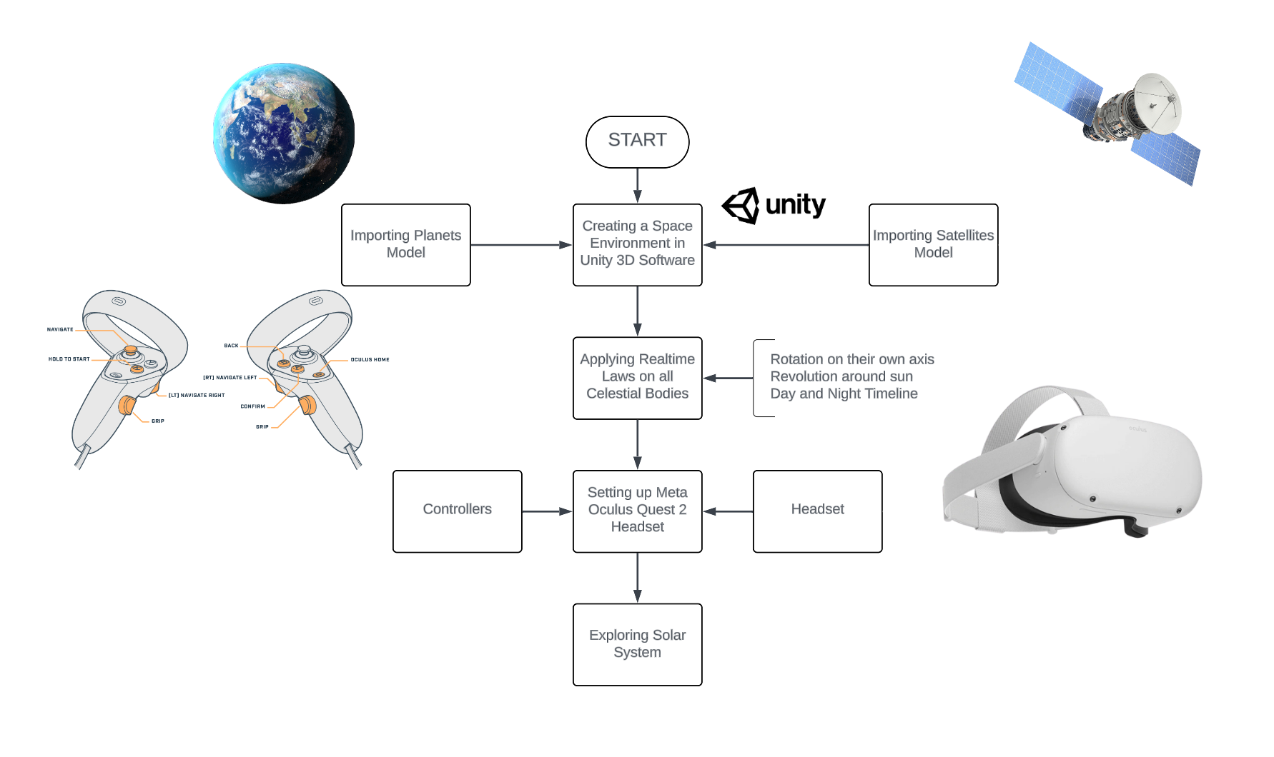
Fig 5.1: Architecture Diagram

5.2 Data Flow Diagram:
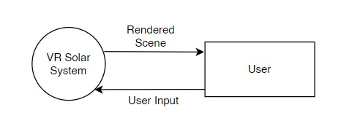
- Level 0
Fig 5.2.I: Data Flow Diagram Level 0
- Level 1
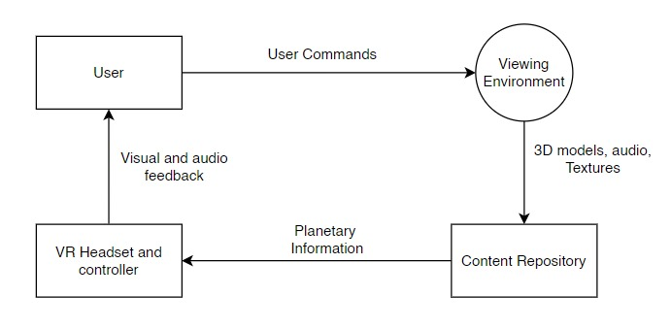
Fig 5.2.II: Data Flow Diagram Level 1
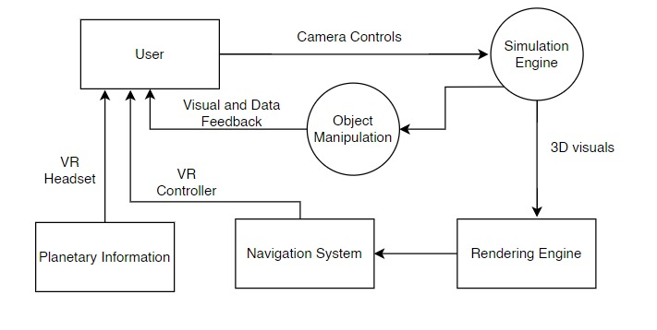
- Level 2

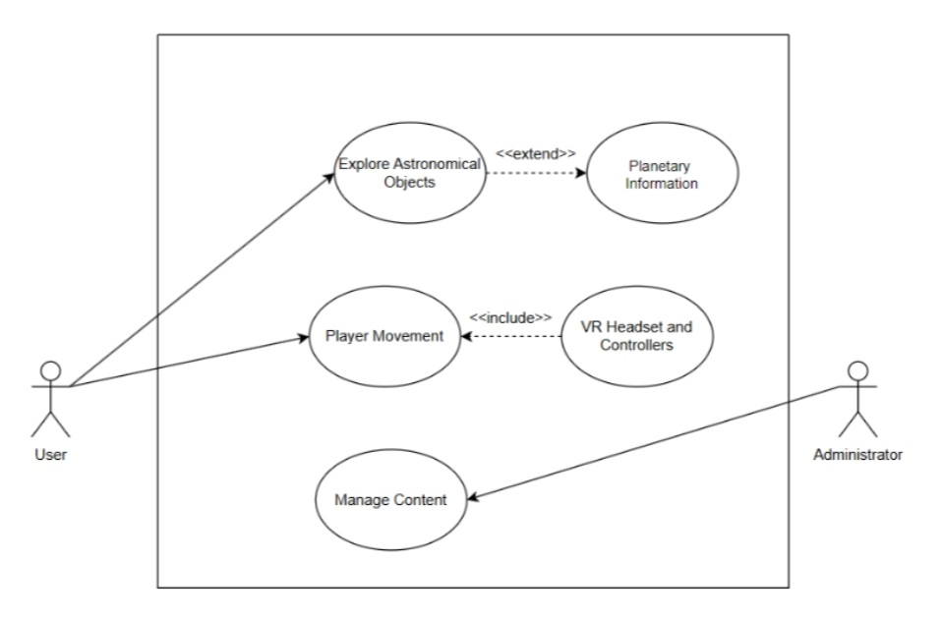
5.3 Usecase Diagram

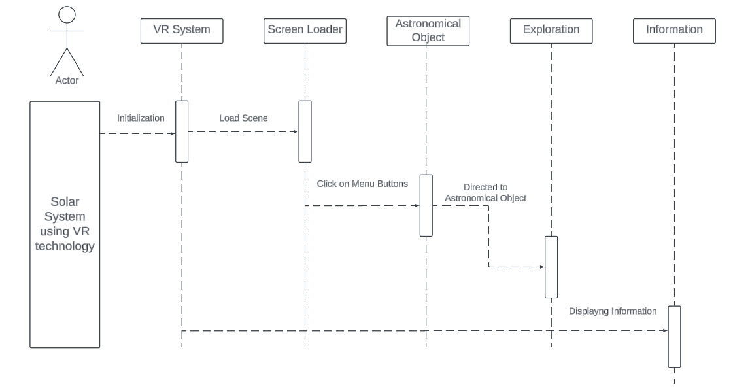
5.4 Sequence Diagram

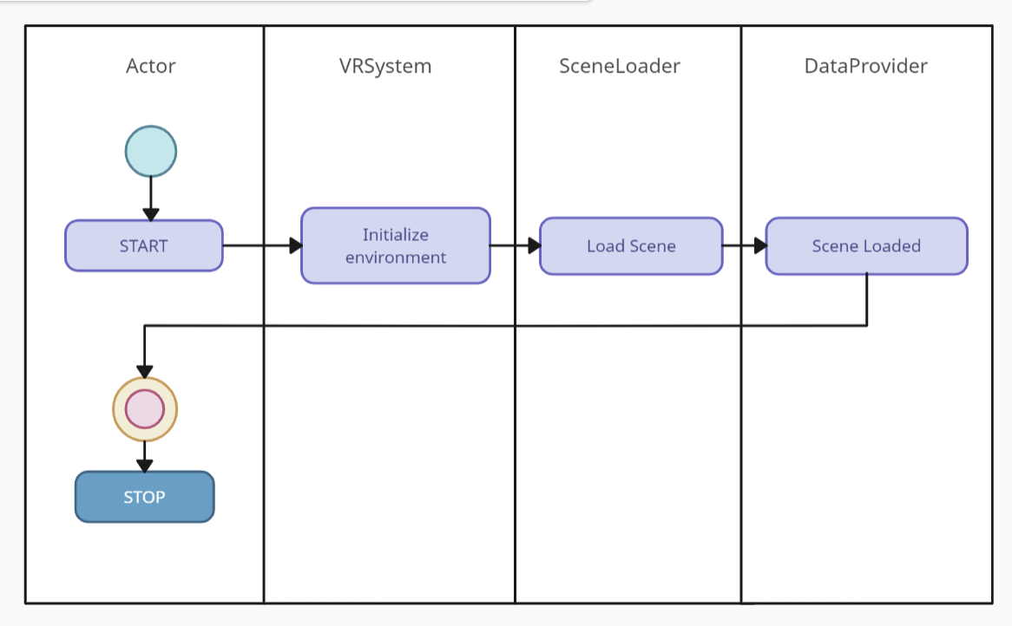
5.5 Activity Diagram

Chapter 6: Experimental Setup

Software Setup:
- Unity
Version: Unity 2021.3 LTS (or later for VR support and stability)
Modules:
Android Build Support (includes Android SDK, NDK, and OpenJDK)
Oculus XR Plugin
Unity VR and AR support
- Oculus SDK
Oculus Integration for Unity: This is necessary for integrating Oculus VR functionalities into your project.
- Visual Studio Code / Visual Studio:
Version: Latest version of Visual Studio(VS2022) or Visual Studio Code(1.94.2) with Unity development support.
Hardware Setup:
- PC Requirements
Operating System: Windows 10 (64-bit) or macOS 10.14 or later
Processor (CPU): Intel Core i5 or AMD Ryzen 5 (or better)

Memory (RAM): Minimum 16 GB (32 GB recommended for larger projects)
Graphics Card (GPU): NVIDIA GeForce GTX 1060 or AMD Radeon RX 580 (or better)
Storage: SSD with at least 10 GB of available space for Unity and project files; more may be needed for assets and builds
USB Ports: At least one USB 3.0 port for connecting the Meta Quest 2 for development and testing
- Meta Oculus Quest 2 Headset Specifications:
Processor: Qualcomm Snapdragon XR2
RAM: 6 GB
Storage: 64 GB, 128 GB, or 256 GB (depending on the version)
Display: LCD, 1832x1920 resolution per eye
Refresh Rate: 72 Hz, 90 Hz, and 120 Hz (adjustable depending on the application)
Tracking: Inside-out tracking with 6 degrees of freedom (DoF)
Controllers: Oculus Touch controllers (motion tracking, haptic feedback)

Chapter 7: Project Plan
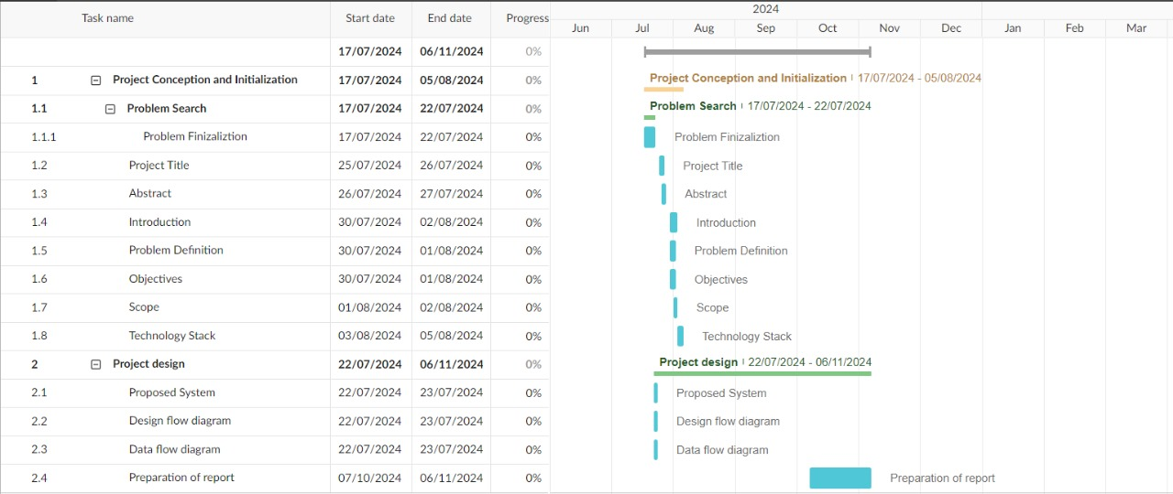

Chapter 8: Conclusion

Leveraging virtual reality (VR) to explore the solar system provides a highly immersive and interactive educational tool that enhances understanding of complex astronomical concepts. Through VR, users can experience planetary systems in a 3D space, offering a unique perspective on the scale, movement, and relationships between celestial bodies. This technology allows for real-time interaction with planetary environments, fostering a deeper comprehension of spatial and scientific principles. The use of VR in solar system exploration not only enriches the learning experience but also provides an innovative platform for scientific visualization, making it a valuable asset in both educational and professional settings.

Chapter 9: References

Alkhattabi, M. (2017). Augmented reality as e-learning tool in primary schools’ education: Barriers to teachers’ adoption. Journal of Education and Practice, 8(12), 212-221.
Bakaç, M., & Akay, C. (2020). Virtual reality in astronomy education: A study of its effectiveness and engagement. Interactive Learning Environments.
Chang, S., et al. (2021). Collaborative learning in VR: Exploring the solar system through group interaction. Computers & Education, 166, 104-109.
Cohen, C., & Hegarty, M. (2012). The effect of visualizations on learning the solar system: Impacts of distance and scale. Journal of Experimental Psychology: Applied, 18(1), 40-52.
Hemmati, A. (2020). Exploring the universe through Google Earth VR: A new frontier in astronomy education. Astronomy Education Review.
Huang, H., et al. (2021). Gamified virtual reality in astronomy education: Learning impacts and engagement. Journal of Science Education and Technology.
Merchant, Z., et al. (2014). Effectiveness of virtual reality-based instruction on students’ learning outcomes in K-12 and higher education: A meta-analysis. Computers & Education, 70, 29-40.
Meyer, K. (2019). Enhancing presentation skills through VR: A new approach to astronomy education. Educational Technology & Society.
Parong, J., & Mayer, R. E. (2018). Learning science in immersive virtual reality: Effects of environment realism and content representation. Journal of Educational Psychology, 110(6), 785–797.
Radianti, J., et al. (2020). A systematic review of immersive virtual reality applications for higher education: Design elements, lessons learned, and research agenda. Computers & Education, 147.
Shin, D., et al. (2020). Unity as a tool for educational VR: Advantages and applications in astronomy education. International Journal of Innovative Technology and Exploring Engineering.
Zhang, Y., et al. (2020). Understanding distances and sizes in the solar system through virtual reality experiences. Journal of Astronomy & Earth Sciences Education.

